Pew Pew

1.0.

Contents

Overview 3

How to Open the Project 4

How to Reskin 6

How to Edit Project Settings 8

How to Set Correct Aspect Ratio 10

How to Change the Build Target 11

How to Change the Grid Colour 12

How to Change Shop Prices 13

How to Change Enemy Health and Number of Particles 14

How to Change Starting Bomb Count 16

How to Set Power up Drops 17

How to Add a New Round (Standard and Challenge) 18

How to Add a New Boss Round 20

How to Change What Happens When You Complete All Rounds 21

# Overview

Gameplay overview: a single screen, round-based game; a modern take on classic games such as space invaders. Enemies spawn on the screen each round and try to reach or shoot the players ship. As the player, you swipe your finger along the bottom of the screen to move the ship. The player’s ship shoots automatically. You can place bombs by tapping on the screen.

When enemies are killed they spawn a number of particles that are attracted to the player’s ship. When these are collected they add to the players point total. Upgrades are purchasable using these points at the end of each round, including: quicker shooting, faster movement, shoot modules (permanent upgrade that attaches to player and shoots enemies), followers (additional weapons that can be destroyed by enemies) and shields.

Every fifth round is a special challenge round. During this round the enemies do not shoot or attack the player’s ship. It is the goal of the player to shoot as many of the ships as possible. At the end of the round a percentage score is calculated and converted to a point’s value to be spent at the shop.

Every tenth round is a boss round. This is a special type of enemy that provides unique challenges and has more hit points than normal enemies. A boss consists of a number of separate parts. Each part has its own movement and shooting patterns. When one part is destroyed the next part is activated.

The background is composed of an optional (can be turned off within the info screen on the main menu) grid that warps and bends based on player and enemy actions.

**The asset was developed using Unity. The specific Unity version used is included in a separate file ‘Unity Version.txt’; this is updated whenever the assets Unity version changes. If possible, please use the specified version of unity when opening the asset.**

Code documentation has been included in a separate file.

# How to Open the Project

The project should open in newer versions of Unity but for full compatibility it is recommended you use the version outlined in the file ‘Unity Versions.txt’. This file is updated whenever the assets Unity version changes.

1. Download and install the correct version of Unity. from: <https://unity3d.com/get-unity/download/archive>
2. Click on the “Open” link (located at the top of the window and shows in the image below) and navigate to the Pew Pew folder.



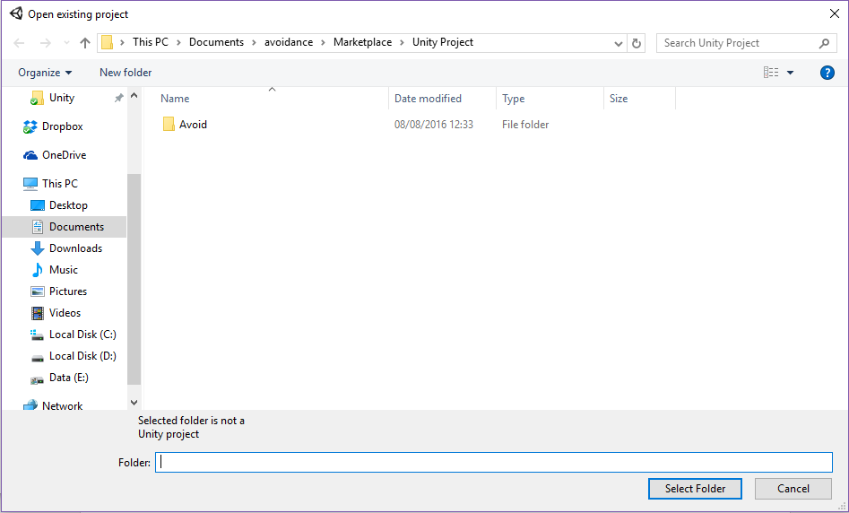

1. You may see a window similar to the one below. This is normally shown when you are attempting to open the asset in a newer version of Unity. If you do, press Continue. Unity will attempt to upgrade the project (you will no longer be able to open it in older versions of Unity).

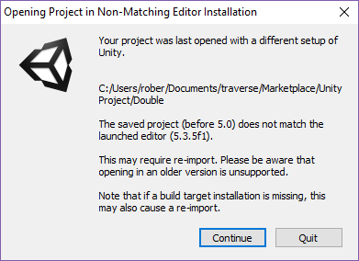

1. Once open, in the Project window, navigate to the Scenes folder. This folder contains any scenes associated with the game. An example game with one scene is shown below.

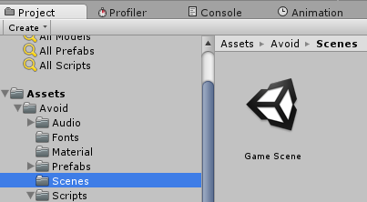

# How to Reskin

**Sprites are located in: Assets/Pew Pew/Sprites/**

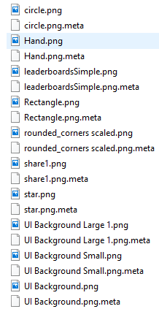

**Audio clips are located in: Assets/Pew Pew/Audio/**

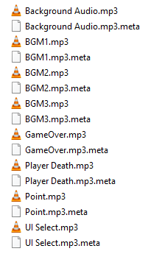

To change the sprites/audio:

1) Ensure project is not open in Unity.

2) Find the sprite or audio clip you would like to replace in a file explorer. Use the above paths as reference.

3) Copy your file into the folder. **Important: ensure your file has the same name as the one you would like to replace.**

4) When asked if you would like to replace the file, select Yes. The file will be overwritten.

You should ignore the .meta files. They are automatically generated and managed by Unity.

Ensure that your sprites have the same dimensions as the originals, otherwise objects may become distorted in the game and require you to manually scale objects in Unity.

# How to Edit Project Settings

To publish to a store, you will need to:

* Provide a unique identifier.
* Set your company name
* Set the product name.

These settings can be changed within unity itself by following the instructions below.

1. Go to Edit -> Project Settings -> Player.

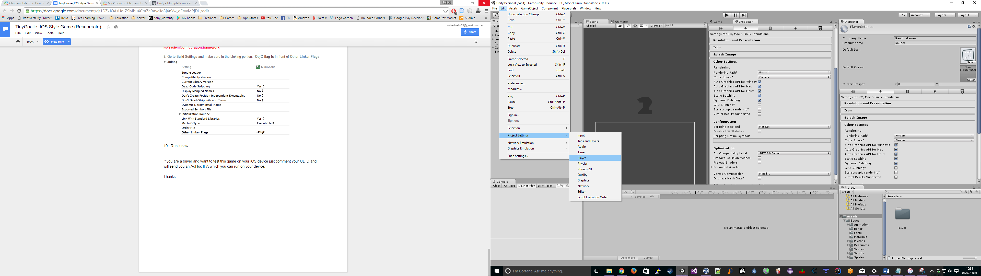

1. The Company Name and Product names are now at the top of the Inspector window.

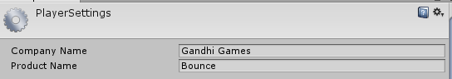

1. Under the Other Settings heading you can set the bundle identifier. This should be a unique identifier for your game and normally follows the structure: com.YourNameOrCompanyName.GameName

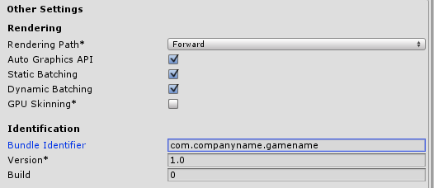

# How to Set Correct Aspect Ratio

The game is designed to run on a horizontal mobile screen. To ensure this is setup properly within Unity, you may need to change the Game windows aspect ratio, as shown in the image below.

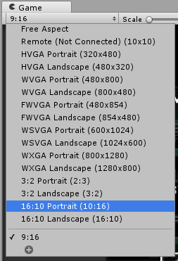

Ensure you select any resolution with ‘Portrait’ in the title. You can also create your own resolution or aspect ratios. In the image above I have created a custom aspect ratio of 9:16, which matches the mobile phone screen used to test the game.

# How to Change the Build Target

With Unity you can publish to a number of different platforms. To target a different platform:

1. Go to File -> Build Settings.

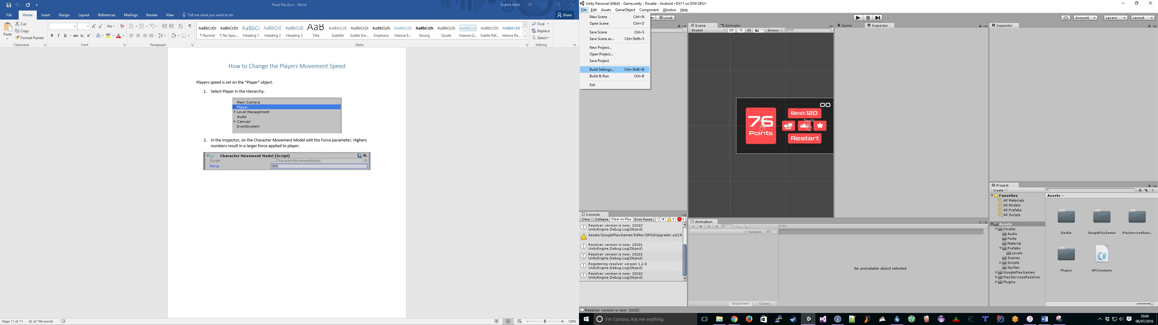

1. Click on a different Platform and the click Switch Platform (bottom left of window).

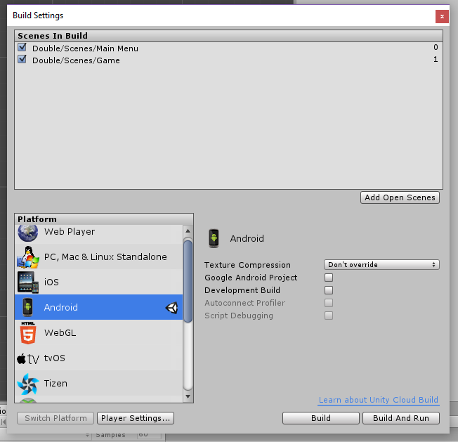

# How to Change the Grid Colour

The Grid colour is set on the ‘Grid’ object in the hierarchy window. The grid colour will need to be changed in both the Main Menu and Game scenes (the process for both are the same).

1. Select the ‘Grid’ object in the Hierarchy.

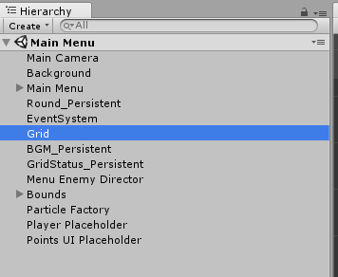

1. Select the coloured box next to the ‘Grid Colour’ variable in the Inspector window.



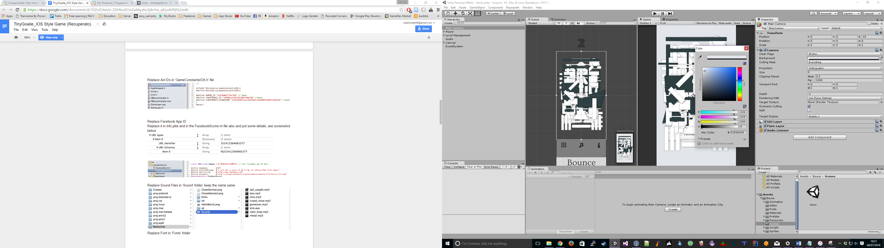

1. Select your desired colour.
2. Save the scene.

# How to Change Shop Prices

1. Open Game scene.
2. In the Hierarchy go to Canvas -> Shop -> Buttons -> Content

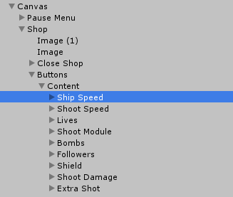

1. Select the shop item that you want to change. In the Inspector, find the cost field associated with the shop item. The script has the naming format: Upgrade **<shop item name>** Actionable. An example for the ship speed item is shown below.

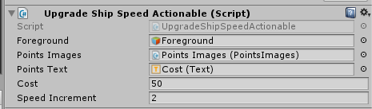

1. Change the cost value. This is the starting cost of the item. After each purchase the shop items cost is doubled.

# How to Change Enemy Health and Number of Particles

Enemy’s health should be changed on a round by round basis.

1. Locate the round that you would like to change (Prefabs/Rounds folder).

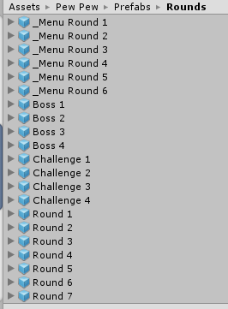

1. Drag the round to the scene view to temporarily add it to the scene.

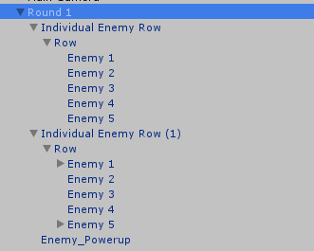

1. If the round is a normal or challenge round (not a boss round), ensure the objects location is 0, 0, 0. If the round is a boss round, ensure that is positioned as outlined below:

* Boss 1: 0, 0, 0
* Boss 2: 0, 0.54, 0
* Boss 3: 0, 0.47, 0
* Boss 4: 0, -1.27, 0

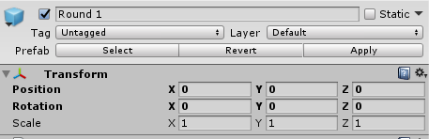

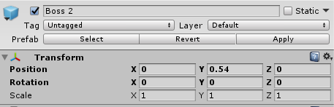

1. Select each enemy in the round and change the Hits Points value if you would like to change their health. You can also edit the number of particles spawned on death and when hit. These particles are collected by the player to spend at the shop between rounds.

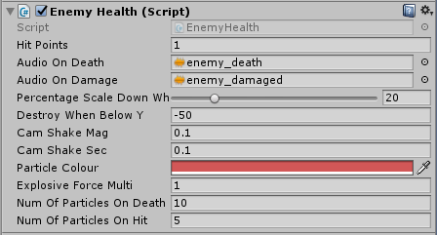

# How to Change Starting Bomb Count

1. Open Game scene.
2. Select ‘Bomb Holster’ in hierarchy.
3. On the ‘Bomb Manager’ script set Initial Bomb Count.

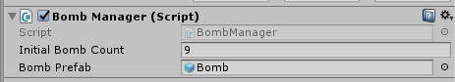

# How to Set Power up Drops

1. Follow steps 1-3 in the section ‘How to Change Enemy Health and Number of Particles’ to add a round with a power up enemy into the scene.
2. Select the power up enemy in the hierarchy.

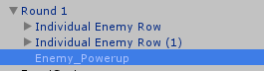

1. Edit the ‘Drop Power Up On Death’ script. You can add or remove power ups that can be dropped. The weight is the relative drop chance of that power up; for example, if an enemy has one power up with a weight of 10, and another with a weight of 1; the power up with a weight of 10 is ten times more likely to spawn.

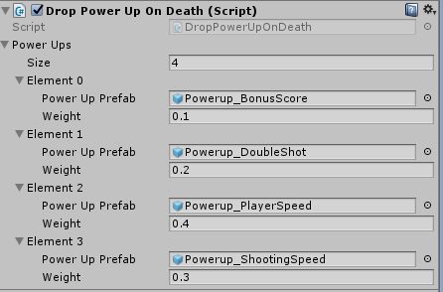

# How to Add a New Round (Standard and Challenge)

The easiest way to add a new round is to edit an existing round.

1. Select the round in the project window that will be your starting point for your new round and then press ctrl-d to duplicate the round.
2. Drag the new round into the scene (ensure it is at position 0, 0, 0).
3. Look through existing rounds for an enemy type you would like to use. Also add that round to the scene. You should now have your new round plus one (or more) rounds whose enemies you would like to use.

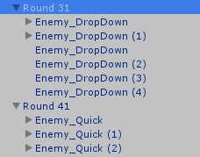

1. Select any enemies from the old rounds that you would like to move to your new round and press ctrl-d to duplicate them.

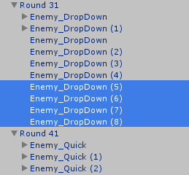

1. Drag the duplicate enemies into your new round. Perform this for any enemies you would like to move to the new round.

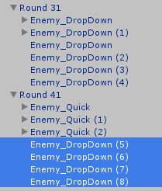

1. Move the enemies to where you would like them positioned.

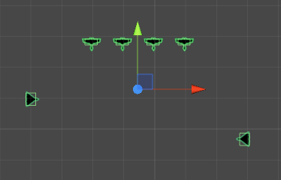

1. Change attributes such as enemy health and number of particles spawned.
2. Make sure you set the correct Round Type by selecting parent object of the round and editing Round Type as shown below.

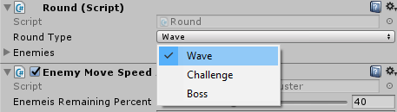

1. Apply changes by selecting parent object of your new round and pressing the ‘Apply’ button in the inspector. This stores your changes to the prefab.

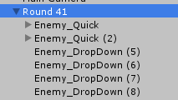

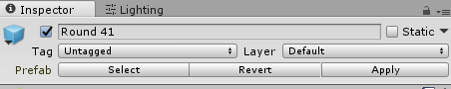

1. Add the prefab to the Game Managers round list. First select the ‘Game Manager’ in the hierarchy and expand the Round Prefabs in the inspector. Drag and drop your new round prefab to the Round Prefabs title (it will then be added to the end of the list). The round will be loaded when the player reaches the last round.

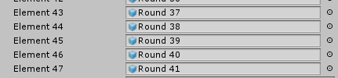

# How to Add a New Boss Round

Creating a new boss round is similar to creating a new round and all of the steps in ‘How to Add a New Round’ apply. There is one difference: boss parts need to be linked (so when one boss part is killed the next part activates).

We assume that you have created a new boss by duplicating an existing boss prefab and changing/adding new boss parts from other boss prefabs (see the ‘How to Add a New Round’ section for detailed instructions). With this complete, the last step is to link the parts:

1. Select the bottom boss part in the hierarchy. This is the part that you want to be activated first.

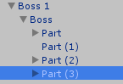

1. View the Boss Part script in Inspector window. **Make sure ‘Is First’ is ticked for the first (bottom) boss part and is not ticked for all other parts**. This sets which part will be activated first.

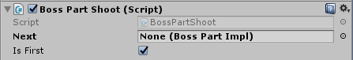

1. Drag the Boss apart above the one you have selected onto the ‘Next’ field. So in this case it would be Part (2).



1. Do this for each part until you reach the top/last part. For the top part leave the Next field empty.

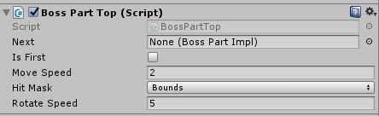

# How to Change What Happens When You Complete All Rounds

Currently the game shows a Game Over screen when the player completes all rounds. To change this follow these steps:

1. Open the ‘GameManager’ script. Located in the Scripts folder.
2. Change the OnRoundsComplete method (shown below).

